

QATIP Intermediate AWS Lab01

A sample Terraform deployment

Lab Objectives 1
Teaching Points 1
Before you begin 1
Task1 Review the sample terraform configuration file 2
Task2 Run Terraform & Test 4
Task3 Examine the state file 5
Task4 Lab Clean-up 5

Lab Objectives
In this lab, you will:
- Review a simple sample terraform deployment configuration file
- Deploy a local Docker image and container
- Test the container
- Modify the deployment
- Test the modified deployment
- Destroy the deployment

Teaching Points
This lab introduces you to Terraform and guides you through using it to interact with locally installed Docker. It introduces providers, used to indicate the infrastructure that will be managed, and also the structure and composition of terraform files. You will review an example terraform file before initializing the client, planning, and then applying the deployment. You will then modify the deployment before eventually destroying it.

Before you begin
- Ensure you have completed Lab0 before attempting this lab.
- In the IDE terminal window, enter the following command
cd ~/environment/aws-tf-int/labs/01
- This shifts your current working directory to aws-tf-int/labs/01. Ensure all commands are executed in this directory
- Close any existing files and use the Explorer pane to open main.tf in the labs/01 folder

Task1 Review the sample terraform configuration file
- In the IDE, open main.tf
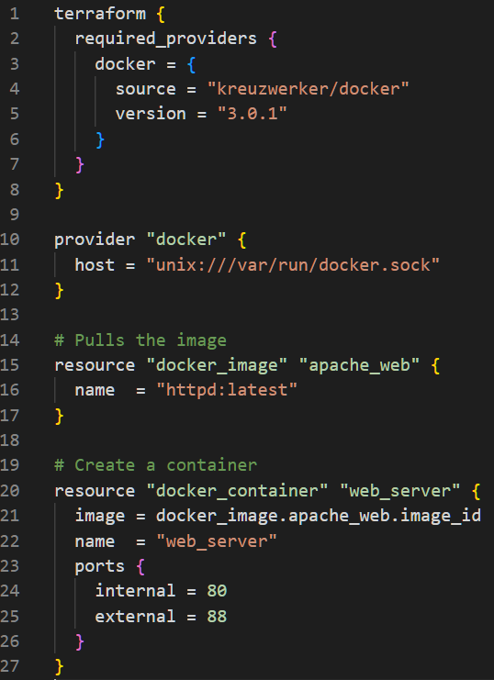
Breaking It Down

Defining the Terraform Block
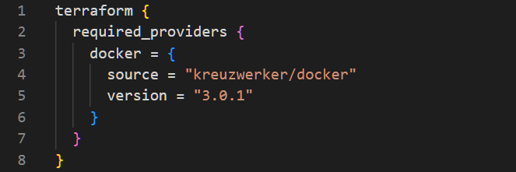
This is the terraform code block. It specifies the provider(s) required for the configuration, here it is Docker, indicating that we want to use Terraform to manage Docker resources. The source section, line 4, identifies the Docker provider component to be downloaded during initialization, and line 5, indicates which version is required.

Initializing the Provider
The provider block details parameters to be used when initializing the Docker provider. The configuration needed here is dependent upon the platform on which Docker is running. We are using Cloud9 here which runs on a Unix derivative operating system.

Pulling the Docker Image
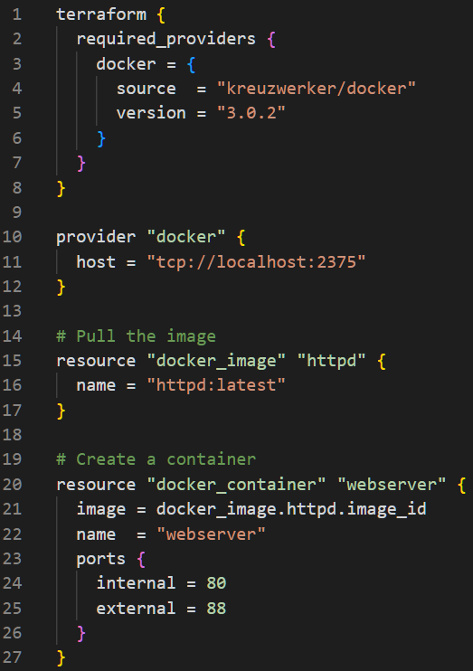
This is one of two blocks of code that indicate the resources we want Terraform to instruct Docker to create. Here we are defining a docker image that needs to be pulled from Docker hub. Line 16 identifies the image we want, the latest version of “httpd”, an Apache webserver.

Creating the Docker Container
This is the second block of code that indicates the resources we want Terraform to instruct Docker to create. Here we are defining that we want docker to create a container called “webserver” (line22) and we want it to be accessible using ports 80 and 88 (lines 24-25). A docker container is created from a docker image. Line 21 indicates that the image to be used to create this container is the one we ask Docker to pull from Docker hub in lines 15-17. This is an example of one resource code block referencing another and it also indicates to Terraform that it must wait for Docker to download the image before it can ask it to create the container using it. This is known as implicit dependency; the container depends upon the image existing.

Task2 Run Terraform & Test
- Run terraform init
- Run terraform plan -- review what will be created
- Run terraform apply typing yes when prompted. Review output in the CLI
- Run docker images in CLI. This should show that httpd image has been downloaded (your IMAGE ID will differ)..
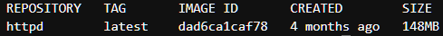
- Run docker ps to list your running containers (your CONTAINER ID will differ)…
- Note the last few characters of your container ID, yours will differ from the one shown above.
- Type curl http://127.0.0.1:88 View the "It Works" response that is standard with an Apache web server (index.html)
- We will now modify the deployment by changing the external port number from 88 to 8088. Some resource changes can be applied to the existing instance of the resource, whilst others require the destruction of the original resource and the creation of a replacement. Let us see whether a port change modifies or recreates this resource.
- Return to the main.tf and change the external port to 8088.
- Save the file
- Run terraform plan and review the changes
- Run terraform apply, typing yes when prompted
- Type curl http://127.0.0.1:8088 This should return a success "it works"
- Type curl http://127.0.0.1:88 An error message is returned.
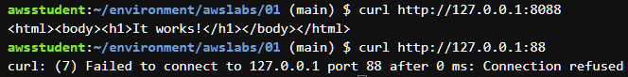
- Run docker ps
- Note that the name of the container is the same, but the ID has changed - Terraform destroyed the original container and deployed a replacement. This is a crucial point to be aware of as we progress through the course. Whether we ‘update’ or ‘replace’ a resource depends upon the resource itself and the changes we make.

Task3 Examine the state file
- When ‘terraform apply’ is run for the first time, a persistent record of resources Terraform deploys and manages is created in the form of a state file, terraform.tfstate. This file is updated whenever you ask Terraform to create, change, or destroy resources thereafter. By default this file will be in your working directory. Click on it now to examine its contents..

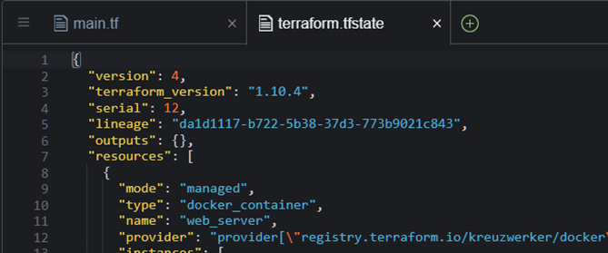

Task4 Lab Clean-up
- Run terraform destroy review the output and type yes
- Run docker ps to confirm your container has been deleted
- Run docker images and confirm your image has been deleted.
- Revisit the state file and view its now reduced content
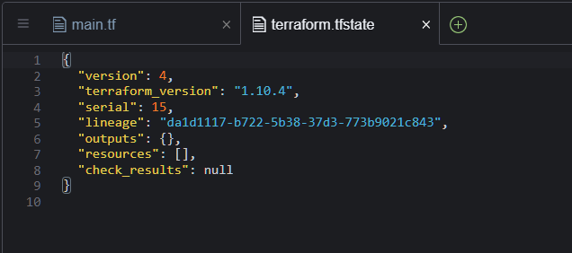

### Congratulations, you have completed this lab ###

Copyright
© 2026 QA Michael Coulling-Green. All rights reserved. These lab materials are provided as part of an authorised training course. Course attendees may reuse these materials for their own personal learning and reference outside of the training session. Unauthorised copying, redistribution, publication, or use of these materials to deliver training is prohibited without prior written permission from the author.

